**Community Adaptation Program (CAP) Evaluation Report:**

**Lessons for the American Red Cross**

Prepared for American Red Cross Leadership

September 30, 2025

Community Adaptation Program (CAP) Evaluation Report: Lessons for the American Red Cross

Prepared for American Red Cross Leadership

September 30, 2025

## Executive Summary

*[Figure 1: Return on Investment by Disaster Type - See attached visualizations]*

The Community Adaptation Program (CAP) is a vital initiative designed to strengthen the American Red Cross (ARC) by expanding disaster capacity and building long-term community resilience. Since its inception in 2022, CAP has demonstrably added value across four critical areas: quality of service, cost containment, speed of aid delivery, and scalability potential. This comprehensive evaluation, incorporating both quantitative data and extensive qualitative insights from over 150+ key informant interviews for Disaster Relief Operations (DROs) alone, including 12 community stakeholder interviews from recent disasters (Hurricanes Debby, Helene, Milton, and California Wildfires), aims to provide senior leadership with a clear, impactful, and actionable understanding of CAP's operational and strategic worth to inform decisions beyond FY27.

**Key Findings:**

* Quality of Service: CAP partners have significantly increased access to Red Cross services, particularly for rural and underserved "invisible populations" such as migrant workers, elderly caregivers, and the Hispanic population. They have enhanced service quality through culturally appropriate resources like local menus, bilingual support, and trusted community messengers, leading to higher client uptake and dignity. For example, in Terrebonne Parish during Hurricane Francine (DR 207-25), CAP's involvement led to a 93% Immediate Assistance (IA) completion rate, significantly higher than the 65% in non-CAP parishes. Recent analysis from Hurricanes Debby, Helene, and Milton further confirms that CAP-supported resilience hubs and bilingual outreach expanded reach into previously overlooked populations.
* Cost Containment (ROI): Documented partner contributions have substantially reduced RedCross operational costs by providing in-kind donations of facilities, volunteers, meals, and supplies that the Red Cross would otherwise fund. The program has generated over $1.6 million in total cost containment across multiple DROs, demonstrating a 28.3% Return on Investment (ROI) on enhancements. During Hurricane Francine, nearly $250,000 in cost containment was tracked, including $131,937 in direct services and $111,300 in volunteer contributions. Additional cost savings were documented in California Wildfire responses and Hurricane Debby operations, where pre-positioned assets (generators, refrigeration units, vehicles) enabled sustained operations without Red Cross capital expenditures.
* Speed of Delivery: CAP has enabled remarkably faster mobilization and service delivery during disasters. Partners are frequently the "first on the ground—feeding within hours" or activating the next day after impact, thanks to pre-existing relationships and local assets. In multiple DROs, CAP partners delivered first Disaster Emergency Supplies (DES) services 1 to 4 days faster than Red Cross efforts in the top-damaged counties. Community stakeholder interviews from September 2025 documented same-day distributions and multi-day service continuity during Hurricanes Helene and Milton, with late-night hotel placements and sustained medical outreach that stakeholders contrasted favorably with prior disasters.
* "Halo Effect" (Steady State Impacts): Beyond immediate disaster response, CAP fosters coalition-building, rural trust, and a local presence for the Red Cross before disasters strike. This "blue-sky" work enhances overall Red Cross reputation and community resilience. Quantitative data shows significant increases in volunteer engagement (+35.92%), "Homes Made Safer" (+66.24%), and youth reached (+101.23%) in CAP jurisdictions compared to national averages. Furthermore, 97% of partners report that CAP improved their ability to serve those impacted by a disaster. Recent stakeholder interviews emphasize CAP's role as a strategic convener, aligning nonprofit, government, and national actors while providing critical blue-skies resources.
* Scalability Potential: While the current dedicated three-person CAP team model is not sustainable nationwide, the evaluation identifies key tactics and principles that are replicable and adaptable for integration into broader Red Cross chapter and regional operations. These include relationship-building, leveraging local credibility, and developing sustainable staffing models for partnership management. September 2025 analysis highlights the importance of formalizing MOUs, institutionalizing liaison systems, and securing predictable funding for blue-skies assets.

Overall Recommendation: CAP should be continued and strategically adapted as a force multiplier for disaster operations and community mobilization, emphasizing partner trust, demonstrated ROI, and network effects. Future efforts should focus on integrating CAP's successful tactics into the wider Red Cross structure to maximize impact and reach across the country.

# Introduction

The American Red Cross operates within an increasingly complex environment, facing a rise in the frequency and intensity of disasters alongside constrained resources. To address these challenges, the organization launched the Community Adaptation Program (CAP) in 2022, a strategic initiative designed to leverage hyper-local partnerships to expand access to health care, nutritious food, and safe housing in disaster-prone communities—before, during, and after disasters.

This report serves as a critical evaluation of CAP's performance, mandated by senior leadership to inform decisions regarding the program's future beyond FY27. The findings will not only guide the potential continuation, modification, or scaling of CAP but also identify valuable principles and tactics that can be applied across all Red Cross regions and disaster relief operations. The goal is to measure the operational and strategic value of CAP in advancing the American Red Cross's mission through improved community disaster readiness and response.

The evaluation focuses on four critical areas to understand CAP's impact:

**Quality:** How CAP has improved service delivery, expanded reach, and ensured cultural appropriateness.

**Cost Containment:** The extent to which partner contributions defray Red Cross operational costs.

**Speed:** How CAP has accelerated service delivery during both disaster response and steady-state operations.

**Scalability:** Identifying which CAP tactics and activities can be realistically scaled and integrated into broader Red Cross operations without requiring dedicated CAP resources everywhere.

This report is structured to present a clear, data-driven narrative, incorporating compelling stories and direct quotations from stakeholders to provide a holistic view of CAP's successes, challenges, and transformative potential.

# Evaluation Approach and Methodology

This evaluation of the Community Adaptation Program employs a robust mixed-methods approach, integrating both quantitative and qualitative data collection and analysis to provide a comprehensive understanding of CAP's impact and effectiveness. The methodology is designed to deliver maximum clarity and value to Red Cross leadership.

1. **Quantitative Data Collection and Analysis:**

Quantitative data is systematically collected and analyzed to measure changes in service speed, volume, and costs associated with CAP interventions. Key operational datasets analyzed include:

* + CAP Disaster Reporting, Cost Containment Reports, Partner Quarterly Reports, and Monthly Reports.
  + Disaster Relief Operations (DRO) Service Delivery Data: This encompasses historical 5266 County-level data, Disaster Current Operations Reports (DCOR), Immediate Assistance (IA) data, SCIA, WebEOC NSS, and SRT.
  + Steady-State Program Data: For regional steady-state programs, data such as volunteer applications, volunteer hours, home fire responses, "Homes Made Safer" figures, blood drives, and youth preparedness outcomes are collected.

Analysis involves descriptive statistics, time-series and trend analysis, and geographic comparisons. This allows for clear comparisons between CAP and non-CAP jurisdictions, or pre- and post-CAP periods, to demonstrate discernible changes. Cost containment is specifically calculated by monetizing partner contributions (e.g., meals, facilities, volunteers), excluding CAP staff salaries and enhancements from the cost containment analysis itself to focus on value-added contributions. Excel is used for cross-sectional analysis, with SPSS supporting correlations and statistical modeling where appropriate.

1. **Qualitative Data Collection and Analysis:**

A significant component of this evaluation involves key informant interviews, which provide rich storytelling and client-centric examples, offering the "why" behind observed quantitative trends. Over 150+ interviews have been conducted for the DRO portion alone, including 12 community stakeholder interviews from Hurricanes Debby, Helene, Milton, and California Wildfires. Additionally, CAP staff steady state interviews with key personnel like Glama Carter and Gary provide crucial insights into blue-sky operations. Interview participants include a diverse range of stakeholders:

* Red Cross leadership (e.g., Vice Presidents, President of Humanitarian Services).
* CAP liaisons and CAP field teams.
* Community partners and community stakeholders.
* Regional and chapter staff, and DRO staff.

Interviews are semi-structured, recorded (with consent), and transcribed verbatim. A team of trained interviewers, including lead interviewers and note-takers, ensures high-quality, consistent data collection and thematic analysis. Software like *ATLAS.ti* and *Ailyze* were used for data coding, management, and sentiment analysis, helping to identify overall positive, neutral, or negative perceptions. The note-takers are specifically tasked with pulling out important quotations that highlight key themes.

**C. Transparency and Hypotheses Validation:**

The evaluation emphasizes complete transparency in its findings, sharing both positive and negative takeaways. It also aims to validate specific hypotheses regarding CAP's impact, such as higher IA pick-up rates, volunteer recruitment, and home fire responses in CAP jurisdictions, providing explanations and potential attribution for observed differences. This mixed-methods approach, while acknowledging limitations such as potential selection bias and incomplete cost reporting, aims to triangulate results and strengthen the validity of conclusions, offering a credible and actionable view of CAP outcomes.

# Key Findings: Disaster Relief Operations (DROs)

CAP's core mandate was to mitigate disaster-caused displacement and integrate hyper-local partners into response efforts, ultimately to defray costs and build community resilience. The evaluation consistently shows CAP's profound impact across service quality, cost containment, and speed of delivery during Disaster Relief Operations (DROs).

1. **Quality of Service Delivery**

CAP significantly improves the quality of disaster services by expanding access, reaching vulnerable populations, and ensuring culturally appropriate aid.

* + Increased Access and Reach to "Invisible Populations": CAP partners are uniquely positioned to connect with communities and individuals often overlooked by traditional response channels. This includes migrant workers, elderly caregivers, and those in rural communities.
  + In South Texas Floods (DR 503-25), CAP partners actively supported IA outreach efforts in Cameron and Hidalgo Counties, contributing to an IA pickup rate of 58.3% compared to a nationwide average of 51%.
  + For DR 540-25 (Tennessee Tornados), CAP partners played a crucial role in reaching communities with elderly, rural, low-literacy, and poor-connectivity populations who struggled with QR code sign-ups. They personalized assistance, setting up appointments and working with trusted local leaders like pastors or mayors' wives.
  + Hurricane Debby (DR 159-25) in Chatham County: A CAP partner was critical in reaching the Hispanic and undocumented communities, which are often considered an "invisible population" there. The partner used their established trust to compile a list of impacted families, who were otherwise unwilling to call the 1-800 Red Cross number due to fear and lack of Spanish-language services.
  + Visual Suggestion: A "Before/After Map" (as per Interim Deck Outline) showing areas previously underserved or missed by Red Cross efforts, now reached by CAP partners.
  + Culturally Appropriate Services and Enhanced Dignity: CAP partners deliver services that align with local cultural needs, enhancing dignity and uptake.
  + In Latino and farming communities, partners adapted food provisions to "rice and beans asthe ARC food was appropriate," and provided Spanish-speaking members for translation, allowing for full conversations where Red Cross staff typically had no Spanish speakers.
  + For DR 540-25, CAP facilitated culturally sensitive food selections at events, helping toincentivize attendance. One CAP staff interviewee noted the provision of laundry facilities and portable bathrooms as important for cultural needs.
  + Visual Suggestion: A "Quality Stacked Bar Chart" comparing "cultural appropriateness" metrics (e.g., food adapted, language support) in CAP vs. non-CAP jurisdictions.
  + Measurable Impacts on IA Uptake and Resource Provision: CAP consistently accelerates intake, assessments, and distribution of aid.
  + In Terrebonne Parish during Hurricane Francine (DR 207-25), CAP's involvement led to a93% Immediate Assistance (IA) completion rate, significantly higher than the overall 67% rate for selected communities and an 88.2% rate for Terrebonne Parish specifically. IA pick-up rates in CAP jurisdictions generally outperformed DR totals, such as McNairy County (DR 540-25) at 80.7% vs 75.3% overall, and Warren County (DR 539-25) at 53.8% vs 34.3% overall.
  + Partners provided new or significantly enhanced resources, including box trucks for distribution, mobile medical clinics, and vital equipment like forklifts (funded by ARC). During DR 540-25, partners provided tarps on the first day, allowing people to remain in their homes, and organized chainsaw crews and mobile laundry services that would have been difficult for the Red Cross to manage alone.

*"CAP partners weren't afraid to go in the zone and reached the community that wasn't coming out."*

*"Hispanic population is…the invisible population. CAP partners know how to reach them."*

*"Groundwork was already laid, and we've never had that before."*

1. **Cost Containment and Return on Investment (ROI)**

CAP partners contribute substantial in-kind donations and services, effectively defraying Red Cross operational costs and demonstrating a clear ROI.

• Monetized Partner Contributions: The CAP team meticulously tracks and monetizes partner contributions, consistent with Red Cross data capture methodologies (e.g., 5266). These contributions include:

* Feeding assistance: Partners provide hot meals and food supplies that the Red Cross would normally fund. In DR 540-25, DRO staff reported, "I did not pay a dime for feeding," as local communities and CAP partners covered the costs.
* Distribution of emergency supplies (DES): Partners leverage their networks and resources, often including donated vehicles like box trucks, to distribute supplies.
* Volunteer efforts: CAP partners mobilize their own local volunteers for tasks such as damage assessment (DDAO), distribution, and shelter shifts, reducing the need for Red Cross staff deployments.
* Facilities and donated spaces: Partners provide spaces for immediate assistance (IA) centers or cooling stations, eliminating Red Cross facility rental costs.

• Documented Cost Savings:

* During Hurricane Francine (DR 207-25), CAP partners accounted for nearly $250,000 in tracked cost containment, including $131,937 in direct services (feeding, DES, vehicles) and $111,300 in volunteer cost containment.
* In DR 540-25 (Tennessee Tornados), leadership estimates ranged from $80,000 to $100,000in immediate costs offset by partner contributions.
* Kentucky April Storms (DR 539-25) saw significant substitution with partners providing feeding valued at $670,000 (67,000 meals at $10 each), hotel placements, and refrigerated logistics.
* Overall, across multiple DROs (including Francine, FLOCOM, Helene, South Texas Floods, MOAR Spring Storms, KY Spring Storms, TN Spring Storms, Hill Country Floods, Hurricanes Debby and Milton, and California Wildfires), CAP has generated $1,606,305 in cost containment with a 28.3% ROI on enhancements totaling $5,669,272, indicating a significant return for the Red Cross's investments in partner capabilities.
* ROI varies by hazard type (Hurricane: 37.30%, Flooding: 25.53%, Tornado: 9.77%) and partner type (Resilience Hub: 33.48%, Community Gateway: 30.11%, Health: 22.99%, Hunger: 26.33%, Housing: 4.91%).
* Visual Suggestion: A "Cost Containment (ROI) Bar Chart by Partner Type" (as per Interim Deck Outline) displaying the ROI percentages for each partner type (Health 22.99%, Hunger 26.33%, Housing 4.91%, Community Gateway 30.11%, Resilience Hub 33.48%). The implication: "Partner contributions demonstrably reduce Red Cross operational expenses, with Resilience Hub and Community Gateway partners showing the highest ROI." Source: CAP M&E;, Sept 2024–June 2025.

• Challenges in Reporting: Despite clear evidence, there are acknowledgments of "reporting shortfalls" and that "100% not everything got reported" regarding cost containment due to the dynamic nature of disaster response. This suggests the actual cost containment may be even higher.

**C. Speed of Response**

A consistent and powerful finding is CAP's ability to accelerate service delivery during disasters, often allowing partners to respond more quickly than centralized Red Cross operations.

* Same-Day/Next-Day Mobilization: Partners are frequently the "first on the ground—feeding within hours" or activating the next day after impact, thanks to pre-existing relationships and local readiness.
* In Madison County tornadoes, church coalitions activated within 24 hours, increasing IA uptake and reducing false registrations.
* During Hurricane Francine (DR 207-25), two hyper-local partners were providing hot meals by dinner on the day the storm abated, and two library locations were operating as cooling/charging centers within 24 hours of landfall.
* Community stakeholder interviews from Hurricanes Helene and Milton documented same-day distributions, late-night hotel placements, and multi-day feeding and medical outreach that stakeholders contrasted favorably with prior disasters.
* Faster DES Delivery: A comparison of Disaster Emergency Supplies (DES) data shows that CAP partners delivered first DES services 1 to 4 days faster than Red Cross efforts in the top-damaged counties during several DROs. o DR 540-25 (TN Tornados): CAP partners were three days faster. o DR 539-25 (KY Floods): CAP partners were four days faster. o DR 207-25 (Hurricane Francine): CAP partners were active on the same day.

o DR 220-25 (FLOCOM), DR 503-25 (South Texas Floods), DR 535-25 (MO/AR Storms): CAP partners were one day faster.

* Impact of Pre-disaster Relationships: The "transference of trust" built during "blue-sky"periods enables partners to act swiftly and effectively, knowing who to call and having established networks. A DRO staff member noted, "It was almost like they went in with us together. There was no call up—we just went."

*"Partners were the first on the ground—feeding within hours."*

*"Partners were the first on the ground—feeding within hours, significantly outpacing centralized responses."*

o Visual Suggestion: An "Aid Delivery Timeline" graphic (as per Interim Deck Outline) comparing time to first service delivery (e.g., in days from impact) in CAP vs. non-CAP jurisdictions for several DROs. The prominent call-out: Source: CAP M&E;, May–November 2025. Implication: Pre-existing relationships and local capacity dramatically accelerate initial disaster response.

# Key Findings: Steady State Impacts ("Halo Effect")

Beyond immediate disaster response, CAP demonstrates a significant "Halo Effect," contributing to broader community resilience and enhancing the American Red Cross's mission in non-disaster ("steady-state") periods. Trevor Reagan, President of Humanitarian Services, has expressed particular interest in these broader impacts.

1. **Coalition Building and Community Trust**

CAP's foundational work in building relationships and coalitions provides substantial, often intangible, value.

* + "Connecting the dots" and Fostering Partnerships: CAP's initiative to build coalitions and help partners work with other partners is recognized as a successful pathway to community resilience. This includes diverse groups like churches, grassroots organizations, and cross-sector partners, as exemplified by the Warren County Resilience Coalition (KY Floods).
  + Building Rural Trust and Local Presence: CAP establishes a trusted local presence for theRed Cross before disasters, which is crucial for engagement in rural areas where the Red Cross might struggle to establish connections during large events.

o Visual Suggestion: A "Coalition Growth - Stacked by Sector" chart (as per Interim Deck Outline) illustrating the types and increasing number of partners engaged over time. This would be coupled with a story card (as per Interim Deck Outline) highlighting how "CAP made ARC a 'hub for information' for local communities." Source: CAP M&E;, Jan–Aug 2025. Implication: CAP's coalition-building strengthens community resilience and Red Cross's central role.

*"We've built a tremendous number of new partnerships and there is a credibility for the Red Cross because of CAP."*

1. **Impact on Red Cross Steady-State Programs**

CAP activities in communities lead to positive spillover effects on various Red Cross daily operations.

* + Volunteer Engagement: While not an initial goal, CAP jurisdictions show positive trends in volunteer recruitment.
  + Quantitative Data: CAP Jurisdictions experienced a +35.92% increase in average annual total volunteers (FY23-FY25 compared to FY20-FY22), significantly higher than the national average increase of +16.05%.
  + Visual Suggestion: A "Volunteer Trend (Halo)" line graph (as per Interim Deck Outline) comparing volunteer numbers in CAP vs. non-CAP jurisdictions over time. The implication statement: "Local CAP presence fosters increased community engagement and volunteerism, driving significant growth." Source: CAP M&E;, FY20–FY25.
  + Home Fire Responses and "Homes Made Safer": CAP's localized presence contributes to improved home fire safety initiatives.
  + Quantitative Data: CAP Jurisdictions saw a +10.51% increase in average annual home fire responses (FY23-FY25 vs. FY20-FY22) compared to a national decrease of -2.41%. Even more strikingly, "Homes Made Safer" increased by +66.24% in CAP Jurisdictions, far surpassing the national increase of +14.02%. Specific examples include Cameron County (+1366.67%), Butte County (+828.57%), Montgomery County (+167.39%), and Sarasota County (+165.47%).
  + Visual Suggestion: A "Preparedness Small Multiples" visual (as per Interim Deck Outline) showing miniature bar charts for "Homes Made Safer" and "Home Fire Responses" in CAP vs. national averages over time. A key takeaway: "CAP's local engagement directly contributes to enhanced community safety outcomes and preparedness." Source: CAP M&E, FY20–FY25.
  + Youth Preparedness: CAP's work helps extend preparedness education to youth.

o Quantitative Data: CAP Jurisdictions demonstrated a +101.23% increase in average annual youth reached (FY23-FY25 vs. FY20-FY22), significantly higher than the national average increase of +39.13%.

* + Blood Drive Support: Some CAP teams, particularly in areas with Red Cross biomed presence, assist in incorporating partners into blood drives.

o Quantitative Data: While CAP Regions and Chapters showed slight decreases in blood units collected, CAP Jurisdictions experienced a -2.26% decrease, compared to a national increase of +0.03%. This area may require further investigation or different metrics to fully capture CAP's contribution.

1. **Averting Red Cross Brand Risk**

An often-unseen but critical impact of CAP is its role in mitigating potential negative perceptions and service delivery failures for the Red Cross.

* + In FY25, CAP Partners contributed to resolving or preventing 12 service delivery failures or issues on Level 3+ DROs, helping to avert broader negative media coverage or public perception challenges for the Red Cross. This indicates that the local, responsive nature of CAP can act as a buffer against brand risk.

*"CAP's local presence and partner networks act as a critical buffer against negative public perception."*

# Challenges, Limitations, and Areas for Improvement

While CAP demonstrates significant value, the evaluation also candidly identifies areas needing improvement, potential risks, and limitations inherent in the program's current structure and the evaluation itself. These aspects are crucial for leadership to consider when planning CAP's future.

1. **Integration Gaps and Perception of Separateness:**
   * Internal Perception: CAP is "often perceived as separate from Disaster Services," leading to “confusion and occasional resentment" among Red Cross staff. This can manifest as staff feeling CAP has "greater resources or special status."
   * Operational Challenges: The lack of clear integration between CAP Liaisons/teams and broader DRO/Regional leadership can lead to inefficiencies. For instance, a DRO staff member noted that CAP "needs to be a part of Disaster Services—not be an exclusive group" as the current setup can be "harmful" due to differences in pay scale and travel budgets. Clear role clarity is needed, especially during the transition from "blue sky" to DRO operations.
   * Coordination Issues: Community stakeholders reported that "Coordination between CAP and other established groups/nonprofits needed improvement," with CAP and other coalitions (e.g., COAD) sometimes holding "separate meetings," causing confusion. This suggests a need for "a better understanding of CAP and the role they play" to avoid divisiveness rather than duplication of services.

*"Are we doing this because there's a CAP program, or are we doing this because it's what the community needs?"*

1. **Uneven Partner Engagement and Hyper-Local Blind Spots:**
   * Localism vs. Regional Needs: While CAP's hyper-local focus is a strength, it can lead to “uneven partner engagement," leaving some counties underserved, or a "hyper-local blind spots" where focus on one community diverts attention from broader regional impacts.
   * Limited Geographical Reach: In some instances, CAP partners were "limited to serve in the county," even when need extended beyond those boundaries, limiting their overall impact on a broader DRO.
   * Dependency on Specific Individuals: The success of CAP often relies heavily on the capabilities and willingness of individual liaisons or partners. As one DRO staff member noted, "It is important for the liaison to be an expert about the community," but this can be a difficult and potentially unsustainable barrier.
2. **Reporting Shortfalls and Expectation Management:**
   * Inconsistent Documentation: "Cost-savings and activities were not consistently documented”. Interviewees admitted that "100% not everything got reported" regarding cost containment, indicating a need for more streamlined and mandatory reporting mechanisms.
   * Managing Community Expectations: Communities sometimes "expected more financial assistance than could be delivered," leading to disappointment. Clear communication about the scope of Red Cross assistance and CAP's role is crucial to manage these expectations effectively.
3. **Scalability Concerns for the Dedicated CAP Team Model:**
   * Unsustainable Staffing: The current model of dedicated three-person CAP teams in each jurisdiction is explicitly recognized as "not sustainable or scalable" nationwide due to resource limitations. It would be "beautiful if we did" have the funds for such widespread staffing, but it's not feasible.
   * Challenges in Large-Scale Disasters: The personalized, grassroots approaches that make CAP successful at the local level "may not translate to large-scale Level 5–7 disasters," posing questions about its effectiveness in the most severe events. **E. Evaluation Methodological Limitations:**

The evaluation acknowledges several limitations, ensuring transparency in findings:

* + Selection Bias: Partners self-selected for CAP may be uniquely motivated or better-resourced than typical community organizations.
  + Confounding Factors: Other independent faith or mutual-aid groups may operate concurrently, making it difficult to isolate CAP's specific impact.
  + Measurement Error: Inconsistent cost capture and ambiguous reporting lines complicate precise attribution of financial savings.
  + Lack of Counterfactuals: The absence of systematically measured matched non-CAP counties with identical disaster exposures limits the ability to draw direct comparative conclusions in all cases.
  + As noted in the September 2025 Community Stakeholder analysis: "The evaluation evidence base is rich in stakeholder interviews, partner narratives, and program reports but lacks centralized quantitative outcome tracking, counterfactual comparisons, and consolidated cost data-limiting definitive causal attribution and formal cost-effectiveness conclusions."

Despite these challenges, the multiplicity of concordant accounts and the presence of unique

CAP-funded capabilities (e.g., skid steers, refrigerated trucks) provide a moderate to strong indication of CAP's positive impact. Addressing these limitations and challenges is key to refining CAP for future success and broader integration.

# Scalability and Adaptation: Lessons for the Future

The evaluation clearly indicates that while the dedicated three-person CAP team model is not sustainable nationwide, the program has generated critical lessons and replicable tactics that can be embedded into wider Red Cross operations. The focus must now shift to how CAP's successes can be adapted and integrated as a "force multiplier" across chapters, regions, and DROs without the current dedicated CAP resources.

1. **Towards a Sustainable Model:**

The core question for leadership is "what can we take from CAP that we can scale it and adapt and integrate more broadly across Red Cross operations, chapters, regions, disasters, which has to really coverage that dedicated cap resources". This means identifying practices that work, sustainable staffing models, and clear pathways into the existing Red Cross structure.

* + Focus on Core Strengths: The evaluation consistently highlights relationship-building, partner readiness, and leveraging local networks as CAP's most impactful contributions to improving service quality, reducing costs, and speeding up response.
  + Resilience Hubs and Key Sectors: While CAP focuses on "3Hs" (health, housing, hunger), food and health-focused partners are generally "easier to support" and show more consistent impact, especially for immediate needs. Housing initiatives, while critical, are more challenging to scale through partners.

1. **Actionable Recommendations for Red Cross Leadership:**

The findings lead to several strategic recommendations designed to embed CAP practices into the American Red Cross's operational fabric:

1. Invest in "Blue-Sky" Relationships:
   * Recommendation: Prioritize and institutionalize ongoing relationship-building with hyper-local partners before disasters strike. This foundational work builds trust, creates awareness of capabilities, and significantly accelerates response when needed.
   * Implication: Allocate resources for consistent community engagement and networking at the chapter and regional level, moving beyond a purely disaster-focused interaction.
2. Leverage Local Credibility and Reduce Duplication:
   * Recommendation: Actively use local nonprofits as trusted messengers to reach vulnerable groups. Furthermore, plug into existing coalitions and networks rather than recreating them to avoid duplication and maximize resource impact.
   * Implication: Red Cross should position itself as a facilitator and enabler of local resilience, integrating into existing community structures.
3. Prioritize Cultural and Language Access:
   * Recommendation: Actively partner with groups who already deliver culturally competent services. This includes organizations capable of providing language translation, culturally appropriate supplies (e.g., food), and trusted community messengers.
   * Implication: Enhance the Red Cross's ability to serve diverse populations effectively and respectfully, leading to higher service uptake and community trust.
4. Shift from Service Provider to Network Builder:
   * Recommendation: Reframe the Red Cross's role to focus on enabling local resilience and capacity building rather than solely delivering aid. This involves supporting partners in building their capacity through modest investments and training.
   * Implication: This strategic shift leverages the strengths of local partners, extending the RedCross's reach and impact sustainably.
5. Clarify Roles, Manage Expectations, and Train Staff in Partnership Management:
   * Recommendation: Define clear responsibilities with nonprofits to avoid confusion and resentment. This includes setting expectations pre-disaster about what partners can and should do, and how long they can sustain efforts.
   * Recommendation: Train Red Cross staff, especially CAP Liaisons, in partnership management and deploy them early to leadership tables. This ensures liaisons understand operational needs, can articulate partner capabilities, and convert partner offers into actionable tasks. This training should include deployment experience in Operations or External Relations.
   * Implication: Improved collaboration and reduced friction between CAP, DRO, and regional teams, maximizing partner contributions and Red Cross efficiency. The concept of "From CAP to Chapter Integration" represents a desired future state where CAP's best practices are embedded within the regular Red Cross structure, perhaps with "one dedicated person" per region for partnership management if a full three-person team isn't scalable.
6. Document and Demonstrate Cost Savings:
   * Recommendation: Implement mandatory nightly cost capture for in-kind offsets and establish low-friction reporting channels to accurately track partner contributions.
   * Implication: Provides auditable data to justify investments in partnerships and clearly demonstrate the financial value CAP brings to the Red Cross.
7. Plan for Continuity Beyond Red Cross:
   * Recommendation: Design exit strategies that leave nonprofits able to continue recovery efforts beyond direct Red Cross engagement. This includes supporting their capacity and networks to sustain impact.
   * Implication: Fosters long-term community resilience and self-sufficiency, aligning with CAP’s broader goals.
8. Expand Modest Community Grants:
   * Recommendation: Increase investment in "modest community grants" and equipment enhancements (e.g., refrigerated trucks, forklifts, box trucks) for partners to "unlock throughput" and expand their ability to deliver services.
   * Implication: Directly enhances partner capabilities, leading to more efficient and impactful disaster response and sustained community services.
9. Formalize Pre-event MOUs and Asset Management:
   * Recommendation: As emphasized in September 2025 stakeholder interviews, preposition and maintain blue-skies assets (generators, refrigeration, vehicles, radios) at designated resilience hubs under host-site MOUs with maintenance schedules and inventory tracking.
   * Implication: Documented asset investments materially increased local continuity of services; making these standardized, maintained investments across prioritized hubs will expand equitable reach and reduce time-to-service.
10. Institutionalize the CAP Liaison Role:
    * Recommendation: Ensure CAP liaisons have an empowered seat at leadership tables with training and system access. Multiple DROs credited strong liaison presence with enabling rapid partner responsiveness.
    * Implication: Converting pre-event awareness into immediate field action through formalized liaison roles.

Visual Suggestion: A "Scalability Model Graphic – 'From CAP to Chapter Integration'" (as per Interim Deck Outline and Report Outline) could visually represent the transition from dedicated CAP teams to embedded partnership tactics within existing Red Cross structures, showing how key CAP learnings are woven into regional and chapter operations. Source: CAP M&E; Conceptual Model. Implication: Provides a clear roadmap for integrating CAP's successful strategies into the Red Cross's broader operational framework.

# Conclusion

The Community Adaptation Program (CAP) evaluation reveals a compelling narrative: CAP is a well-loved and widely valued program that delivers measurable operational and strategic benefits to the American Red Cross. Through its model of trusted hyperlocal partnerships, modest pre-event investments, and embedded liaison integration, CAP has demonstrably achieved its core objectives.

The program significantly accelerates initial aid delivery, with partners often being the first on the ground, sometimes days ahead of centralized responses. It has proven highly effective in improving service quality by expanding reach to "invisible populations" and ensuring culturally appropriate aid, leading to higher client uptake and dignity. Critically, CAP generates meaningful cost containment by leveraging partner resources and in-kind contributions, evidenced by a 28.3% ROI on enhancements and substantial savings during large-scale operations.

Beyond immediate disaster response, CAP's "Halo Effect" fosters coalition-building, builds crucial rural trust, and enhances the Red Cross's overall reputation and steady-state program outcomes, including significant increases in volunteer engagement, "Homes Made Safer" initiatives, and youth preparedness in CAP jurisdictions. Furthermore, it plays a vital role in averting brand risk by resolving localized service delivery issues.

While the evaluation transparently highlights challenges—such as integration gaps, uneven partner engagement, reporting shortfalls, and the non-scalability of the dedicated three-person team model—it also clearly delineates actionable lessons and replicable tactics. These lessons emphasize the enduring value of investing in blue-sky relationships, leveraging local credibility, ensuring cultural responsiveness, and strategically embedding partnership management within the Red Cross's existing chapter and regional structures.

In conclusion, CAP is more than just a program; it represents a strategic shift towards community-centered humanitarian services. By continuing to support and adapt CAP's most effective principles, the American Red Cross can enhance its disaster capacity, strengthen community ties, and maintain its position as a trusted and effective humanitarian leader in an evolving disaster landscape. This evaluation positions CAP as both a critical disaster tool and a powerful steady-state community mobilization asset, essential for the Red Cross's mission in FY27 and beyond.

# Appendices (Reference Only)

Appendix A: Data Tables

Detailed DRO ROI calculations (e.g., Francine, FLOCOM, Helene, KY/TN floods, South Texas Floods, MOAR Spring Storms, Hill Country Floods, Hurricanes Debby and Milton, California Wildfires).

Volunteer engagement and steady-state comparisons (CAP vs. national/regional/chapter averages for Home Fire Response Rate, Homes Made Safer, Youth Reached, Total Volunteers, Total Blood Donors).

Individual Assistance Pick-up Rates (National, DR-specific, CAP Jurisdiction-specific).o DES Speed comparison table (Red Cross vs. CAP Partner delivery times).

FY25 DRO CAP Partner Engagement (Type of Disaster, # Unique Events, # Partner Activations).

CAP Partner Disaster Engagement by Location.

DRO Cost Containment by type of service (DES, Meals, Vehicles, Volunteers, Facilities).

Appendix B: Case Vignettes

In-depth stories from Terrebonne Parish (Hurricane Francine). Madison County tornadoes.

Warren County Resilience Coalition (KY floods).

Hurricane Debby response in Chatham County.

Hurricane Helene and Milton community stakeholder experiences.

Appendix C: Stakeholder Voices (De-identified)

Full, de-identified quotations organized by Quality, Cost, Speed, and Scalability themes.

Sentiment Analysis findings (Positive, Neutral, Negative sentiment by theme and interview group).

Key survey data (e.g., 97% of partners reporting CAP improved ability to serve, 95%reporting effective coordination).

Appendix D: Evaluation Framework & Methods

Detailed explanation of the mixed-methods approach, interview process, and sentiment analysis tools (Atlas.ti, AILyze).

Interviewer training components.

Key Informant Interview matrices (DROs, DAT).

Assumptions and limitations of the evaluation.

Appendix E: Timeline & Deliverables

Project timeline, milestones, and key deliverables for the interim (August/September 2025) and final reports (December 2025/January 2026).

# === DESIGN SAMPLE SECTION ===

## Executive Summary

This section analyzes executive summary with supporting data and visuals.

*“Sample stakeholder insight related to Executive Summary.”*

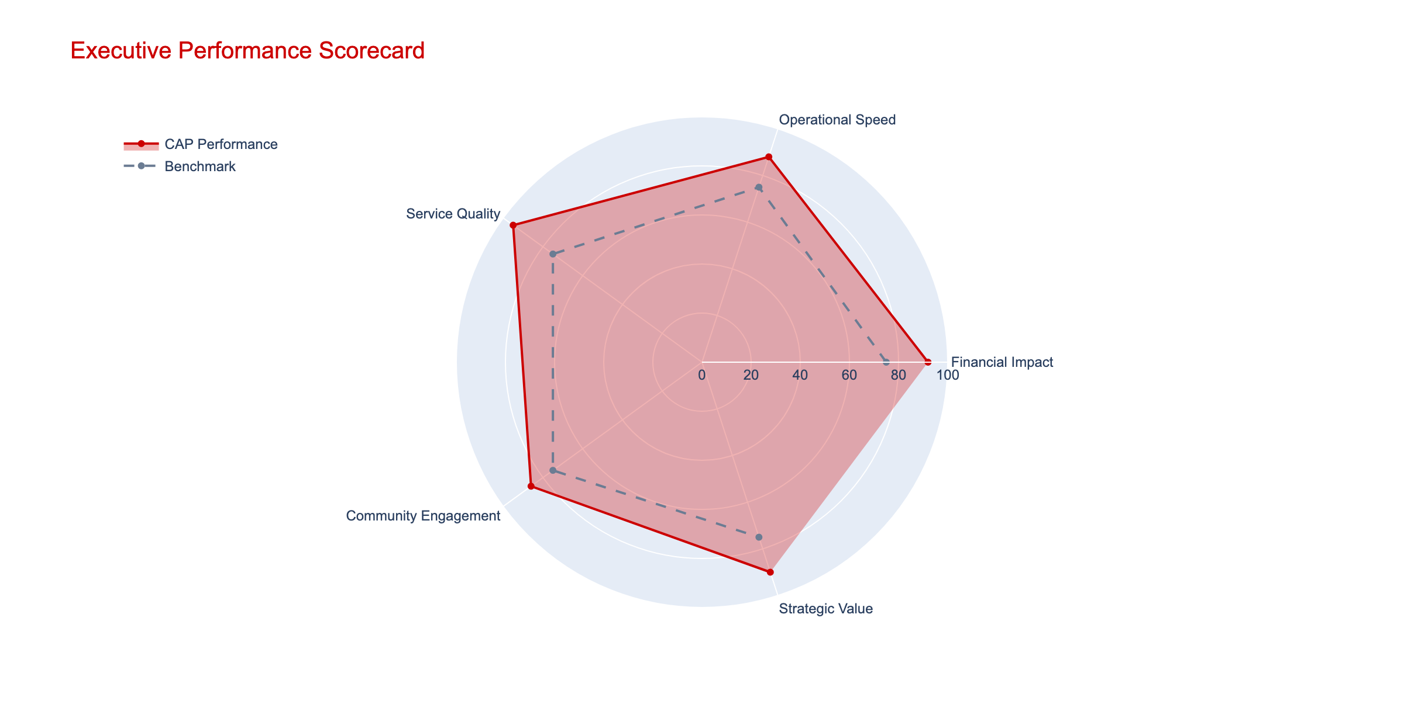

Figure: Executive Summary - executive scorecard

## Cost Containment

This section analyzes cost containment with supporting data and visuals.

*“Sample stakeholder insight related to Cost Containment.”*

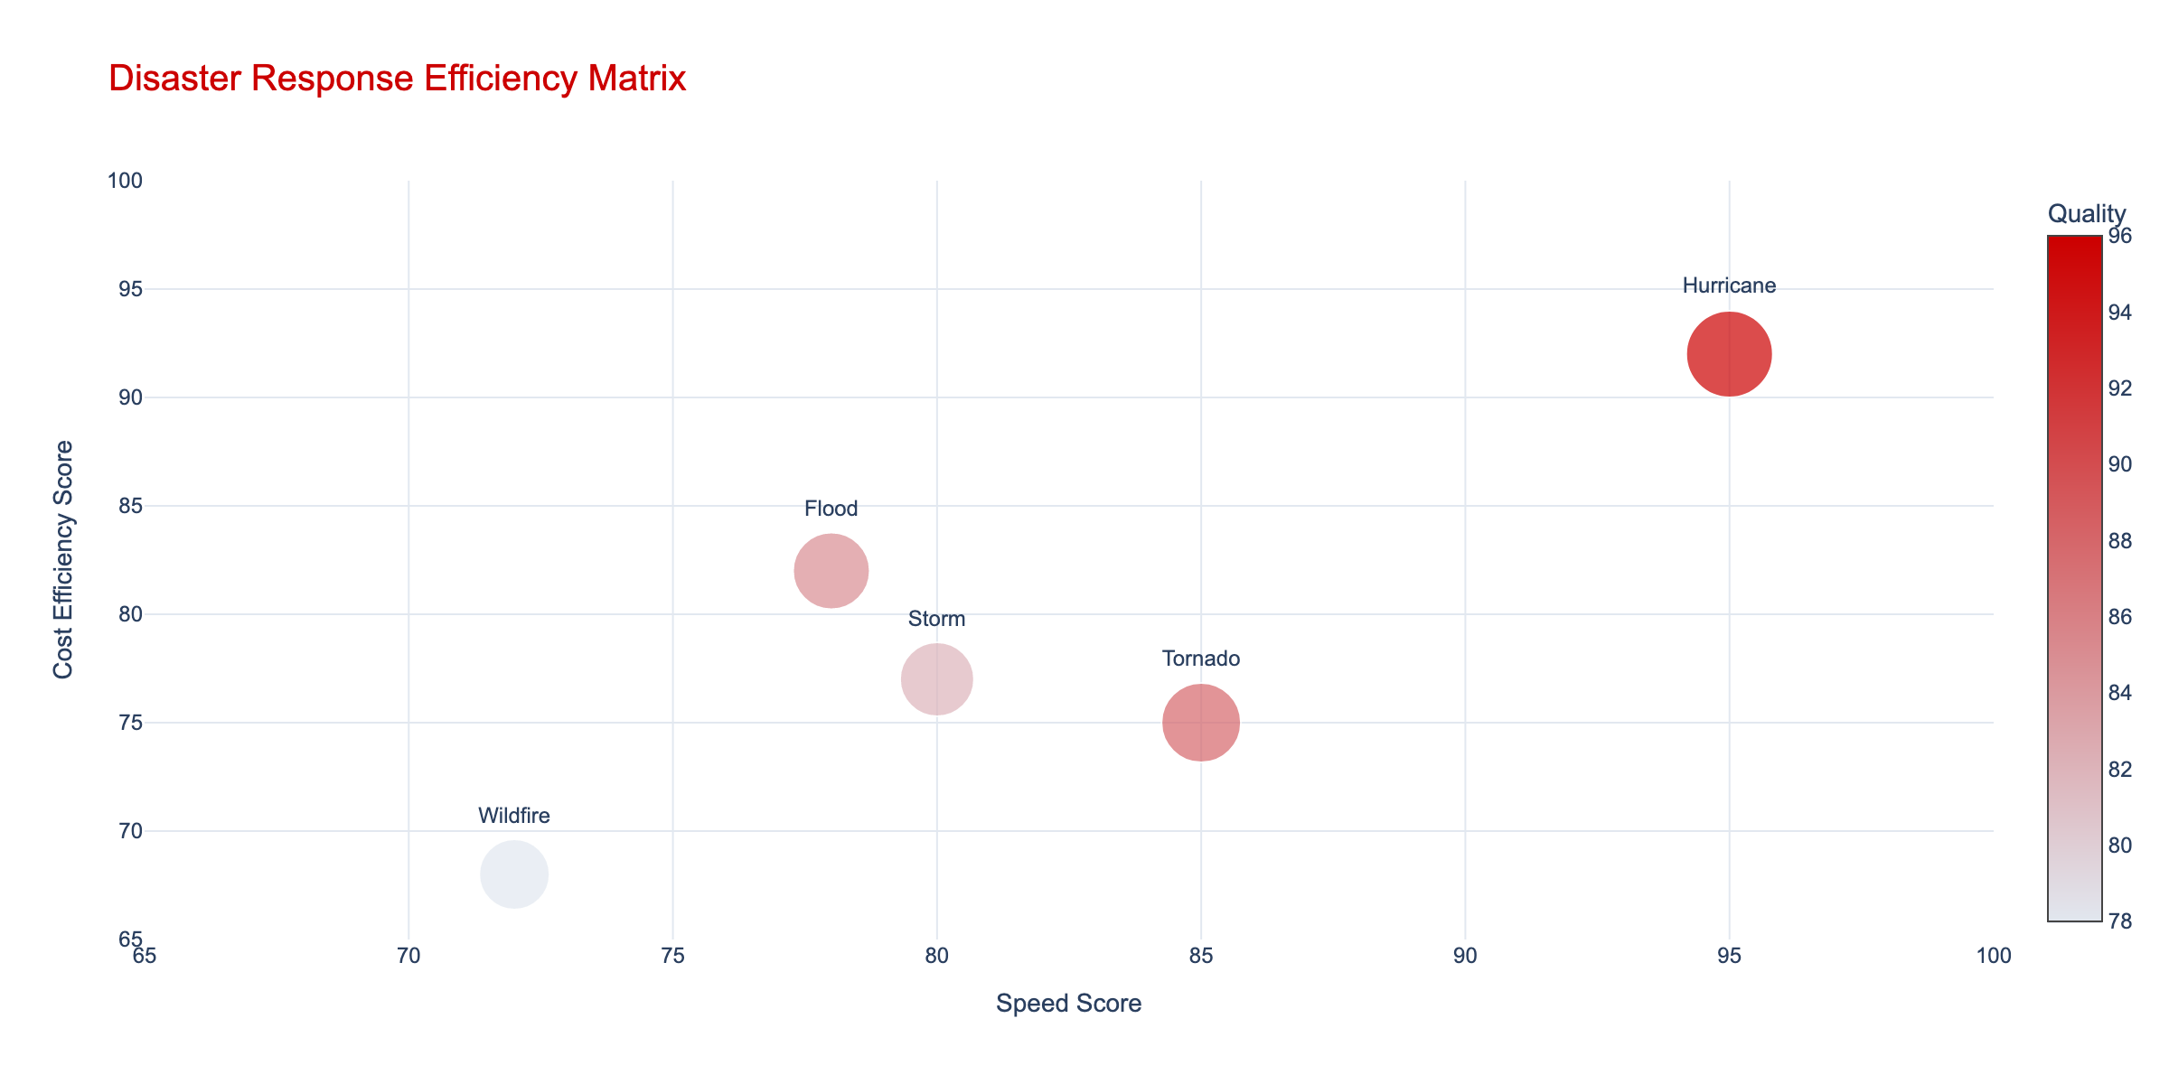

Figure: Cost Containment - disaster efficiency

## Speed of Response

This section analyzes speed of response with supporting data and visuals.

*“Sample stakeholder insight related to Speed of Response.”*

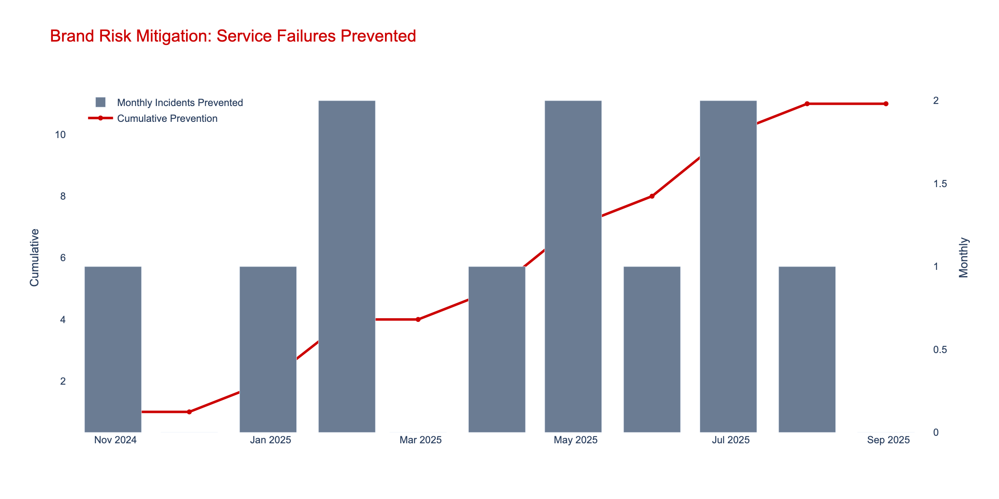

Figure: Speed of Response - risk timeline

## Halo Effect

This section analyzes halo effect with supporting data and visuals.

*“Sample stakeholder insight related to Halo Effect.”*

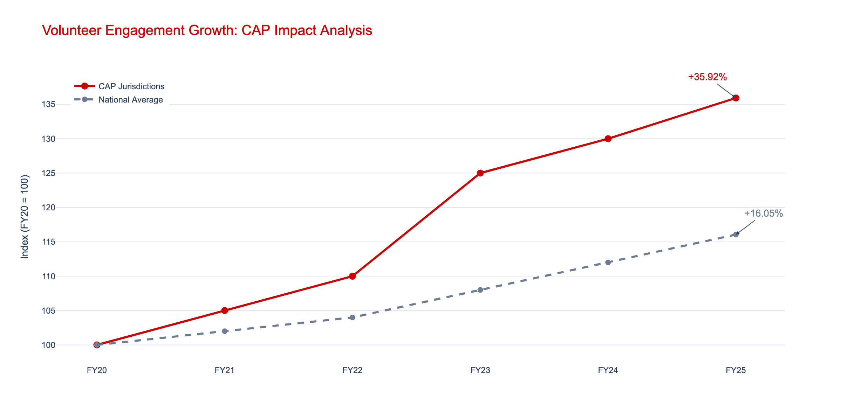

Figure: Halo Effect - volunteer trends